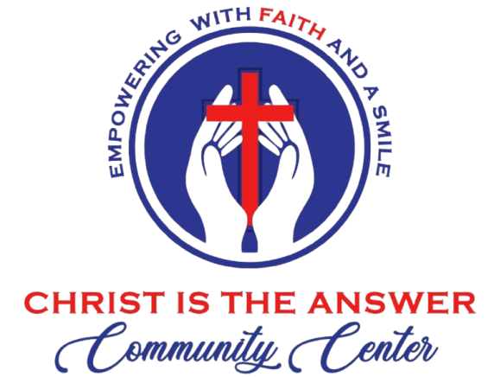

CITACC Volunteer Servant Application
“Using Purposeful Talents to Shine His Light”
I. Volunteer Information
- Full Name: ___________________________________________________________
- Phone & Email: ________________________________________________________
- Area of Interest: (e.g., Lab Assistant, Student Mentor, Admin, Outreach)

II. Commitment to the Code of Conduct
At CITACC, our conduct is a witness to the world. Please review our core standards and indicate your commitment:
- Christ-Centered Integrity: Are you committed to reflecting the character of Jesus through absolute honesty and ethical behavior in all your tasks?
[ ] Yes [ ] No
- Compassionate Communication: Do you agree to speak with kindness and resolve all conflicts with the gentleness and grace of Christ?
[ ] Yes [ ] No
- Stewardship of Talents: Do you view your volunteer role as a purposeful talent meant for humble service rather than personal recognition?
[ ] Yes [ ] No
- Protection of Minors: Our campus is a sanctuary. Are you committed to the safety, protection, and godly encouragement of every minor at CITACC?
[ ] Yes [ ] No
- Digital Witness: Will you uphold our standards for ethical technology use, ensuring your digital presence glorifies our Father in heaven?
[ ] Yes [ ] No
III. Heart for the Mission
- Reflecting Hope: Our organization is built on the belief that Christ is the Answer to the challenges we face. How does your daily life or current service reflect your desire to share this hope with others?

- Every Life We Touch: How do you plan to share the "Light of Christ" through your specific volunteer role?

IV. Safeguarding & References
To ensure a safe environment for our families and minors, we require the following:
- [ ] I consent to a background check.
- Pastoral/Character Reference Name: _______________________________________
- Phone/Email: __________________________________________________________

V. CITACC Volunteer Commitment
“Each of you should use whatever gift you have received to serve others, as faithful stewards of God’s grace.” — 1 Peter 4:10
I have explored the CITACC Community Covenant and joyfully embrace our shared vision. I believe that Jesus Christ is the answer to the burdens of those we serve, and I am honored to walk alongside this community as a faithful volunteer, anchored in His grace.
Signature: _______________________________________ Date: _______________

