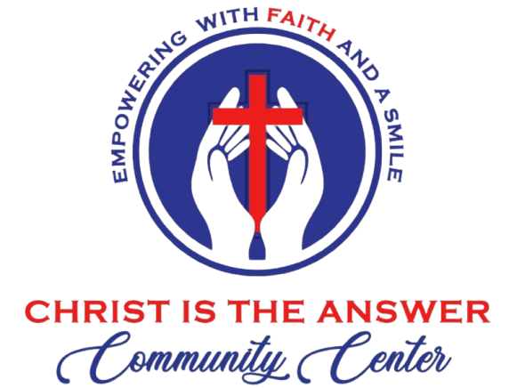

CITACC Covenant Support Application
“Partnering in Grace to Serve the World”
I. Applicant Information
- Full Name: ___________________________________________________________
- Email Address: ________________________________________________________
- Phone Number: ________________________________________________________
- DATE: ________________________________________________________________

II. Reflection & Heart Alignment
After reading the Statement of Faith and Vision on our website, we would love to hear your heart:
- Resonance: How do you feel about this mission and vision after reading it? What specifically resonated with your heart?

- The Core Foundation: At CITACC, we believe Christ is the answer, and we welcome everyone with His unconditional love. How do you see yourself supporting this vision on our board?

III. Sharing Your Gifts
“Each of you should use whatever gift you have received to serve others...” (1 Peter 4:10)
What purposeful talents or abilities would you like to bring to the CITACC family?
(e.g., teaching, prayer, administrative help, organizing community events, etc.)

IV. Level of Commitment
“Counting the Cost of the Mission”
- Calling: On a scale of 1 to 10, how deeply do you feel called to this specific vision?
[ ] 1 [ ] 2 [ ] 3 [ ] 4 [ ] 5 [ ] 6 [ ] 7 [ ] 8 [ ] 9 [ ] 10
- Priorities: Are you prepared to prioritize the spiritual well-being of the individuals and families we serve above technical or personal success?
[ ] Yes [ ] No
- Endurance: If the mission faces challenges, are you committed to staying anchored in God’s peace and working toward wholeness through grace?
[ ] Yes [ ] No
V. Leadership & Unity: To restore hope and help our youths and community thrive, we serve in unity. Do you commit to leading like Christ did—with a warm, compassionate heart—while lifting them in prayer and upholding the CITACC constitution?
( ) Yes, I’m ready to serve in unity
( ) I’d love to discuss board commitments further
- Community Covenant: Have you read and do you agree to uphold the CITACC Community Covenant?
( ) Yes ( ) No
VI. Covenant Commitment
“By submitting this application, I express my sincere desire to partner with CITACC. I commit to being a faithful steward of the resources and talents God has given me to further His Kingdom through this purposeful calling.”
Signature: _______________________________________ Date: _______________

Privacy Statement: At CITACC, we value your trust. Your information is held securely and will only be used to facilitate your partnership with our ministry. We will never share or sell your data to third parties.

